Upload files through API

---------------------------------

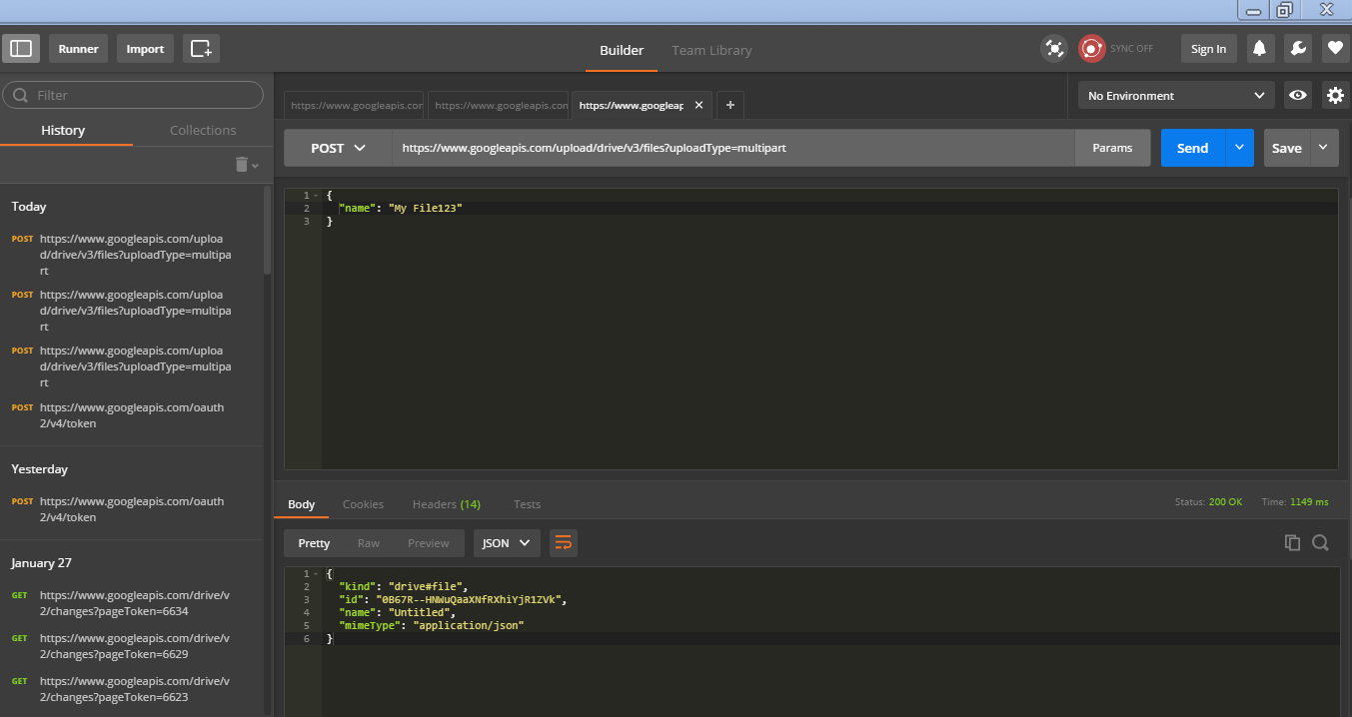

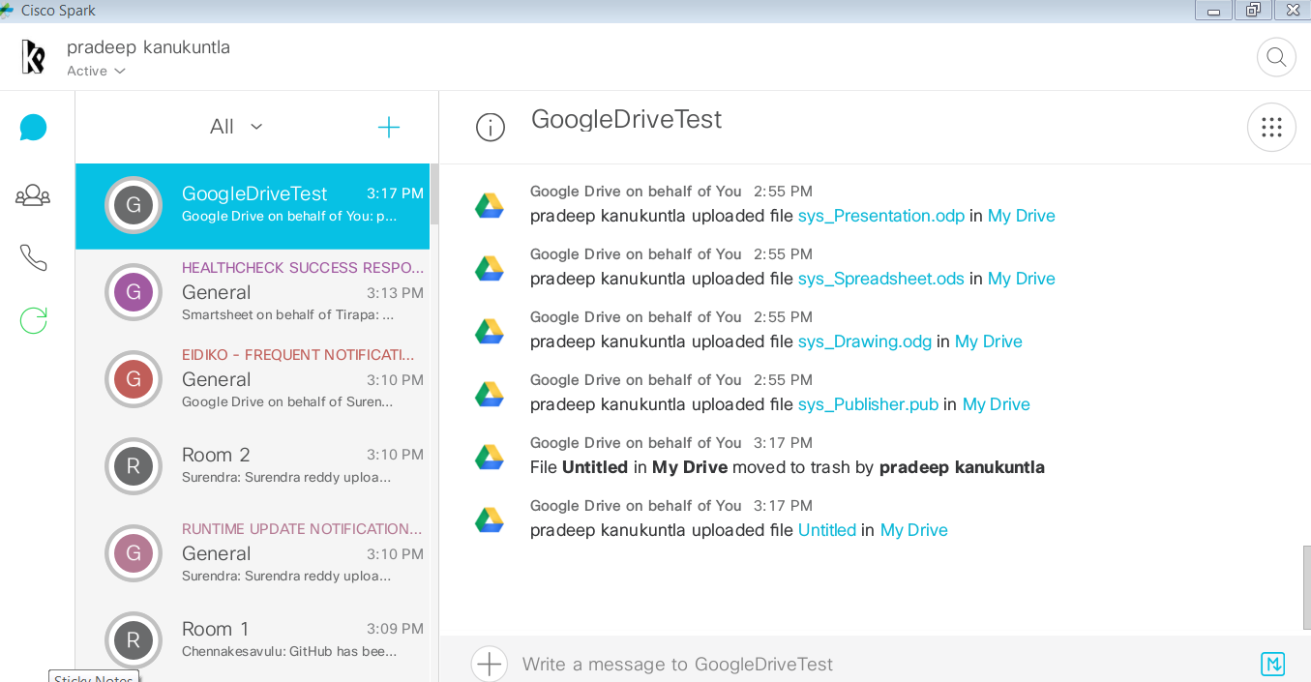

Delete Through API

-----------------------------

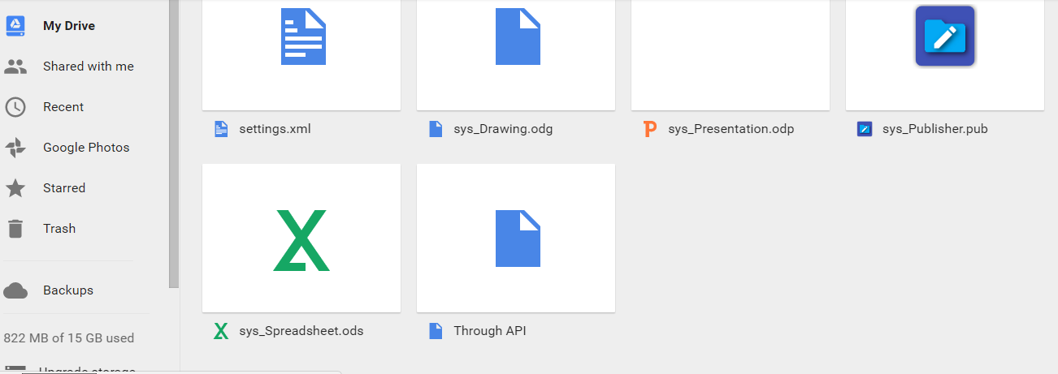

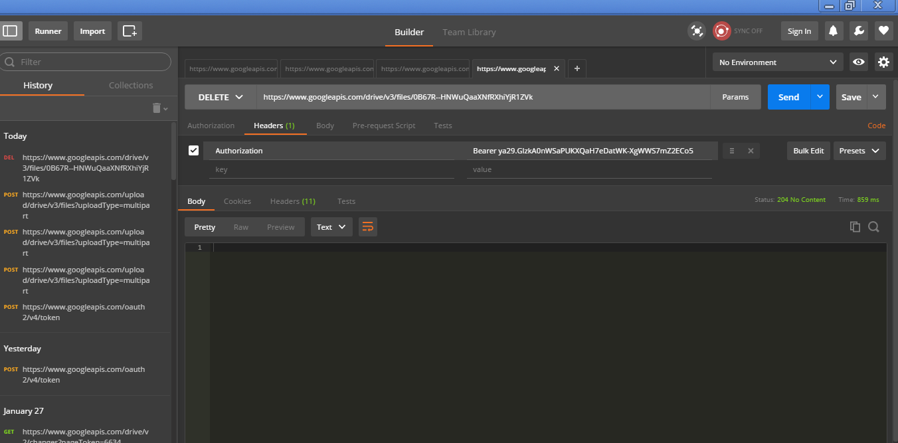

{

"kind": "drive#changeList",

"etag": "\"LbWe7Ybz7gmJtEmo4LFBfsRw3MM/bri2ED-oO240KtKfZzRC4r-4DWg\"",

"selfLink": "https://www.googleapis.com/drive/v2/changes?pageToken=6748",

"largestChangeId": "6750",

"items": [

{

"kind": "drive#change",

"id": "6750",

"fileId": "0B67R--HNWuQaWVFUODltZWRfWEE",

"selfLink": "https://www.googleapis.com/drive/v2/changes/6750",

"deleted": true,

"modificationDate": "2017-01-31T10:01:46.360Z"

}

]

}

comments through API

-------------------------------

